3. The following values of y = f(x) give the displacement in inches of a certain machine part for the rotation x of the ﬂywheel. Write a MATLAB function to expand y in terms of a Fourier series upto four harmonics. Plot the graph of the same using MATLAB and record the output.

|  |  |  |  |  |  |  |  |
| --- | --- | --- | --- | --- | --- | --- | --- |
| x | 0 | π/6 | 2π/6 | 3π/6 | 4π/6 | 5π/6 | π |
| Y=f(x) | 0 | 9.2 | 14.4 | 17.8 | 17.3 | 11.7 | 0 |

and f(x + π) = f(x)

∗ Take a print of MATLAB code along with output and graph, then attach this sheet with the sheets in which you have answered ﬁrst two questions.

**MATLAB code to find the Fourier series for the function f(x):**

function [] = n_harmonics( x,y,n,T )

a=[];

b=[];

for i=1:n

a(i) = (2*sum(y.*cos((i*2*pi*x)/T)))/length(x);

b(i) = (2*sum(y.*sin((i*2*pi*x)/T)))/length(x);

end

a0 = (2*sum(y))/length(x);

a = [a0 a];

syms t

fs = a(1)/2;

for i=1:n

fs = fs+a(i+1)*cos((i*2*pi*t)/T)+b(i)*sin((i*2*pi*t)/T);

end

fprintf('the required fourier series is: \n')

disp(vpa(fs,3));

plot(x,y,'o')

hold on

t = linspace(x(1),x(end),1000);

y1=eval(fs);

plot(t,y1,'k')

end

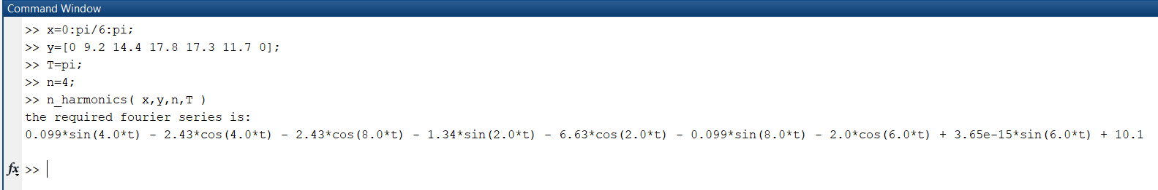

Figure 1 required Fourier series

**Output:**

>> n_harmonics( x,y,n,T )

the required fourier series is:

0.099*sin(4.0*t) - 2.43*cos(4.0*t) - 2.43*cos(8.0*t) - 1.34*sin(2.0*t) - 6.63*cos(2.0*t) - 0.099*sin(8.0*t) - 2.0*cos(6.0*t) + 3.65e-15*sin(6.0*t) + 10.1



Figure 2 graph of Fourier Series of f(x)